In our simulated driving experiments, subjects exhibited repeated episodes of dozing off, accompanied by consistent patterns in EEG and EOG signals. When dozing off, an alpha wave attenuation-disappearance phenomenon and alpha blocking phenomenon alternates in the eye-closed periods. As illustrated in Figure, the alpha wave attenuation-disappearance phenomenon exhibits a distinct attenuation pattern during an eye-closed period labeled as Doze², where alpha waves persist until a specific time point before nearly disappearing thereafter. Additionally, alpha blocking—a reduction in alpha rhythm due to visual stimulus attention (e.g., eye opening)—was observed during another eye-closed period labeled as Doze¹in the Figure 1.

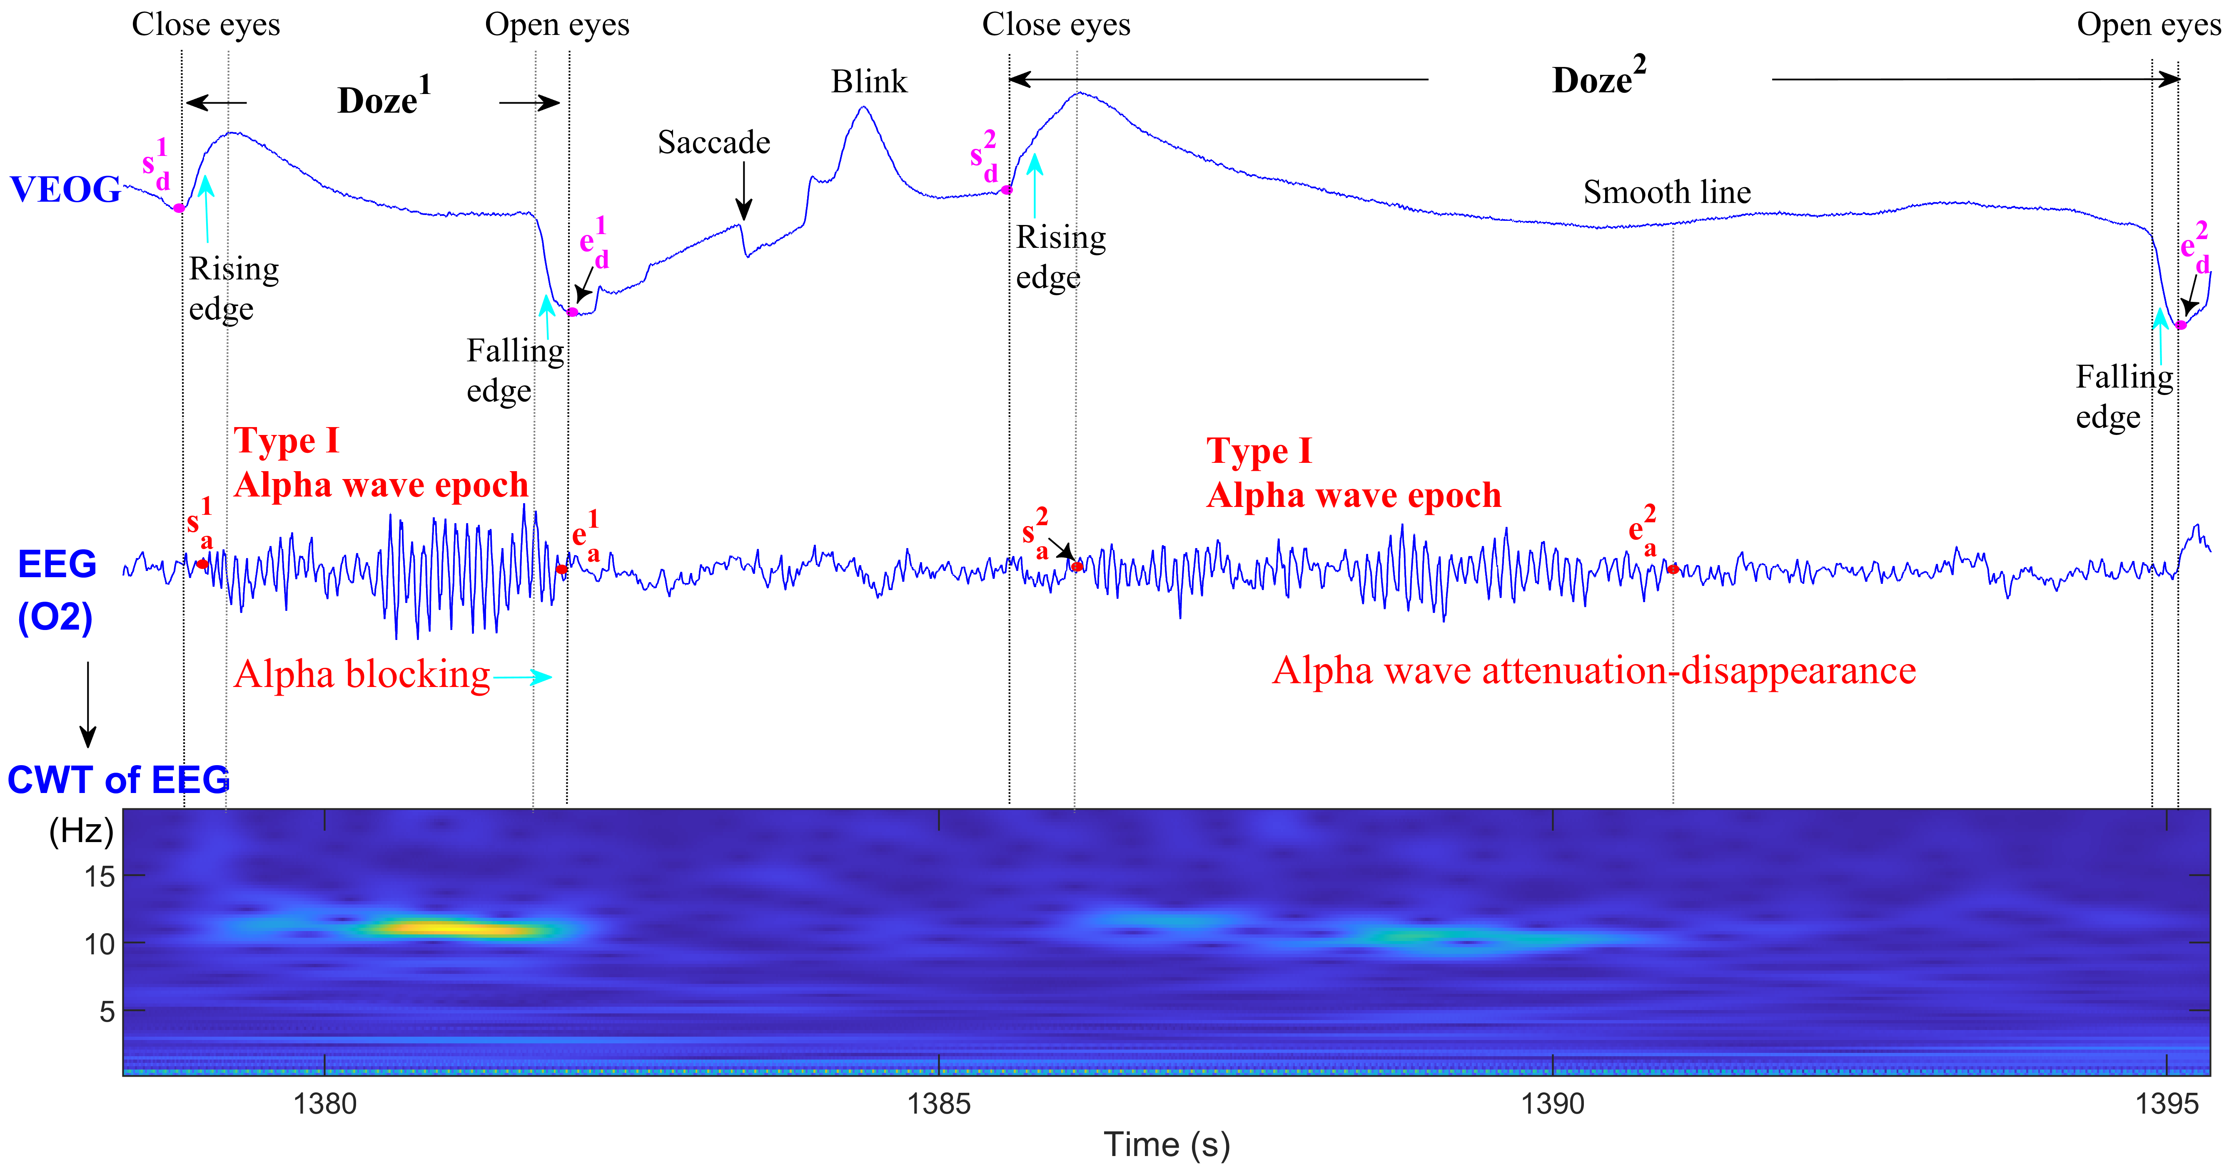
Figure 1. Two types of dozy states: (1) Type Doze1 is with alpha blocking phenomenon; (2) Type Doze2 is with alpha wave attenuation-disappearance phenomenon.

As illustrated in the Figure 1, we manually labeled the signals as follows: (1) the Type I alpha wave epoch (AWE), whose start and endpoints are s_a1 and e_a1 in Doze1, or are s_a2 and e_a2 in Doze2 ; (2) the rising edge waveform, whose start point is s_d1 in Doze1 or s_d2 in Doze2; (3) the falling edge waveform, whose end point is ed1 in Doze1 or s_d2 in Doze2. A complete dozy state is defined as the period between the start time point sd1 (or sd2) of the rising edge cased by closing eyes and the end time point ed1 (or ed2) of the falling edge caused by reopening eyes. Type I alpha wave epoch (AWE) occurs at the onset of a doze and is characterized by continuous alpha waves. The start time point of Type I AWE is labeled as sa1 or sa2 and its end time point is labeled as ea1 or ea2.

The detection of physiological indicators such as alpha waves, rising/falling edge waveform, was effectively formulated as a classification problem, solvable through machine learning or deep learning approaches. The proposed framework consists of three interconnected sub-modules, each implementing a dedicated CLSA model for specific binary classification tasks. the proposed framework consists of three interconnected sub-modules, each implementing a dedicated CLSA model for specific binary classification tasks:

- Alpha wave detection module. The alpha wave detection task is formulated as a time-series binary classification problem. During model development, CLSA 1 was trained using a two-class windowed data samples (alpha wave present vs. absent) to derive the optimal model M1. These two-class windowed data samples are obtained by applying window 1 (1-s duration) as a sliding window across all labeled AWEs and non-AWEs, respectively.

The CLSA model was simulated using the Keras deep learning framework, with Windows 11 as the operating system and an NVIDIA GeForce RTX 3060 GPU with 12.0 GB of dedicated memory. The program code for this model was executed in Python 3.8 through Anaconda Navigator, utilizing the Pandas, Keras, and Scikit-learn libraries.

